PROGRAM OBJECTIVES-PHARMACY
To provide solid foundation in pharmacy possessing basic knowledge and comprehensive understanding of Profession of Pharmacy
To prepare student graduates for a successful career in Pharmacy Profession with effective planning skills, problem analyzing skills, leadership skills, communication skills, and professional ethics
To train student graduates in learning, selecting, and applying appropriate methods, procedures, and resources of modern tools in Pharmacy Profession
Create dynamic and proficient Pharmacists for their successful careers in Pharmaceutical industry, academia, government organization, hospitals, and other organizations and as an entrepreneur
To train the students to promote practice of Pharmacy for improving and sustaining quality of life
To shape pharmacy graduates equipped with knowledge and skill to cater to the health-care needs of the society
To create state of art facilities to upgrade the technical skills of the students
To inculcate in student graduates, ability to gain multidisciplinary knowledge through innovative projects, industrial training, industrial visits, visiting research institutions, health care communities, health promoters, employees and employers
To promote environmental consciousness, cultural heritage, social, spiritual, and human values
To promote and enhance the quality of Pharmacy education and make student globally competent
PROGRAM OUTCOMES-PHARMACY

PO1: Pharmacy knowledge: Apply the knowledge of pharmacy fundamentals and an pharmaceutical specialization to the solution of complex pharmaceutical problems
PO2: Problem analysis: Identify, formulate, research literature, and analyze complex pharmaceutical problems reaching substantiated conclusions using first principles of natural sciences, mathematical, and pharmaceutical sciences
PO3: Design/Development of solutions: Design solutions for complex pharmaceutical problems and design system components or processes that meet the specified needs with appropriate considerations for public health and safety, and the cultural, societal, and environmental considerations
PO4: Conduct investigations of complex problems: Use research-based knowledge and research methods including design of experiments, analysis and interpretation of data, and synthesis of the information to provide valid conclusions
PO5: Modern tool usage: Create, select, and apply appropriate techniques, resources, and modern pharmaceutical tools including prediction and modeling to complex pharmaceutical activities with an understanding of the limitations
PO6: The Pharmacy and society: Apply reasoning informed by the contextual knowledge to assess societal, health, safety, legal and cultural issues and the consequent responsibilities relevant to the professional pharmaceutical practice
PO7: Environment and sustainability: Understand the impact of the professional pharmaceutical solutions in societal and pharmaceutical contexts, and demonstrate the knowledge of, and need for sustainable development
PO8: Ethics: Apply ethical principles and commit to professional ethics and responsibilities and norms of pharmaceutical practice
PO9: Individual and team work: Function effectively as an individual, and as a member or leader in diverse teams, and in multidisciplinary settings
PO10: Communication: Communicate effectively on complex pharmaceutical activities with the pharmacy community and with society at large, such as, being able to comprehend and write effective reports and design documentation, make effective presentations, and give and receive clear instructions
PO11: Project management and finance: Demonstrate knowledge and understanding of the pharmaceutical and management principles and apply these to one’s own work, as a member and leader in a team, to manage projects and in multidisciplinary environments
PO12: Life-long learning: Recognize the need for, and have the preparation and ability to engage in independent and life-long learning in the broadest context of technological change

PROGRAM SPECIFIC OUTCOMES-PHARMACY
To impart fundamental knowledge of structure and functions of various systems, their biochemical aspects, patho-physiological roles and the therapeutic management through pharmacological science
To inculcate among the students the knowledge and technical skills to carry out synthesis and analysis of drugs as well as develop, manufacture, market pharmaceuticals and cosmetics
To develop among the students the knowledge and technical skills of biopharmaceutical aspects and bioassays as well as screening of drugs for pharmacological actions
To inculcate the knowledge and technical skills of identification, standardization of drugs obtained from natural origin, herbal drugs as well as development of herbal formulations and cosmetics
To train the students and develop their technical skill knowledge for handling sophisticated analytical instruments
To create a talent pool by involving students in research projects and to make students undertake research projects under faculty guidance for publication
To foster ambitious desire among students to undertake higher studies and career growth
To establish industry institute partnership cell to bridge the gap between the industrial requirements and the academic curriculum
To improve patient care in performing medication history, interpretations of laboratory data of biological samples, identifying potential-drug related influences of Pharmacotherapy
To establish systems management as an entrepreneur through inventory control, distribution systems, documentation, analysis of financial resources, utilizing management theories, and information technology in industrial Pharmacy and Business Management

School of Pharmaceutical Sciences
BOS Members
UG Board of Studies

S.No | Name | Post | Contact Address
1 | Dr.P.Shanmugasundaram | Chairman | Director, School of Pharmaceutical Sciences,  Vels University  Chennai
2 | Dr.S.Jayakumari | Professor | Professor and Head,  Department of Pharmacognosy  School of Pharmaceutical Sciences  Vels University
3 | Dr. S. Sathesh Kumar | Professor | Professor and Head,  Department of Pharmaceutics  School of Pharmaceutical Sciences  Vels University
4 | Dr. M.Vijey Aanandhi | Professor | Professor and Head,  Department of Pharmaceutical chemistry and Analysis  School of Pharmaceutical Sciences  Vels University
5 | Dr. S.Santhosh Kumar | Professor | Professor and Head,  Department of Pharmacology  School of Pharmaceutical Sciences  Vels University
6 | Dr.T.S.Shanmugarajan | Professor | Professor,  Department of Pharmaceutics  School of Pharmaceutical Sciences  Vels University
7 | Mr.M.Ashok Kumar | Associate Professor | Department of Pharmacy Practice  School of Pharmaceutical Sciences  Vels University
8 | Dr.A.Vijayalakshmmi | Associate Professor | Department of Pharmacognosy  School of Pharmaceutical Sciences  Vels University
9 | Mr.I.Somasundaram | Assistant Professor | Department of Pharmaceutics  School of Pharmaceutical Sciences  Vels University
10 | Mrs. V.Jayashree | Assistant Professor | Department of Pharmacology  School of Pharmaceutical Sciences  Vels University
Subject Experts
11  12 | Mr.C.Venkatasubramaniyan | Expert (Industry) | Senior Scientist, Formulation Development, Par Formulations Pvt. Ltd., Kelambakkam, Chennai
 | Dr.R.Sundhararajan | Expert (Academic) | Professor and Principal  M.S.A.J College of Pharmacy, Sholinganallur.
13 | Mr.M.Shivanandhaperumal | Alumni | Territory Sales Executive, Sun Pharma,3/4, Old Tower Block Street, 1st Extension, Nandanam, Chennai-35
CURRICULUM STRUCTURE
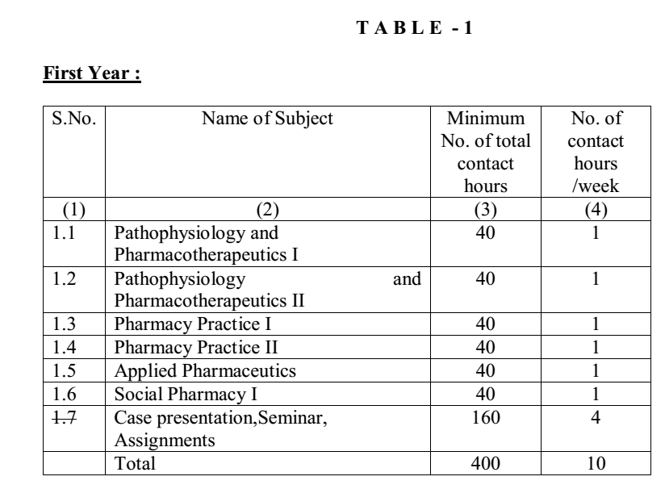
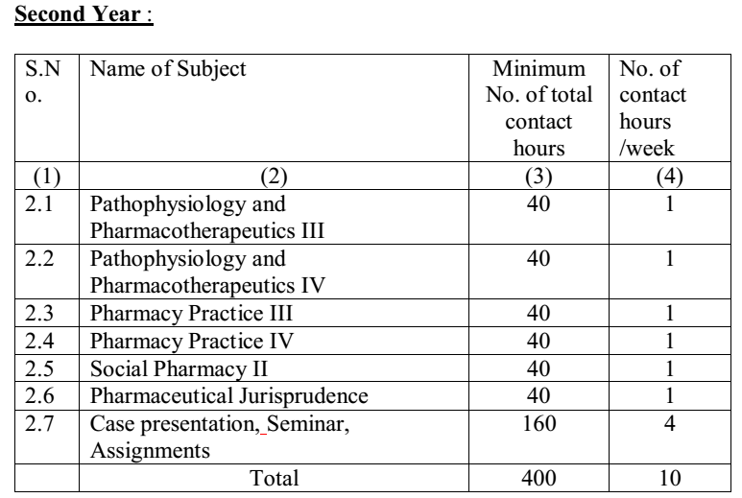
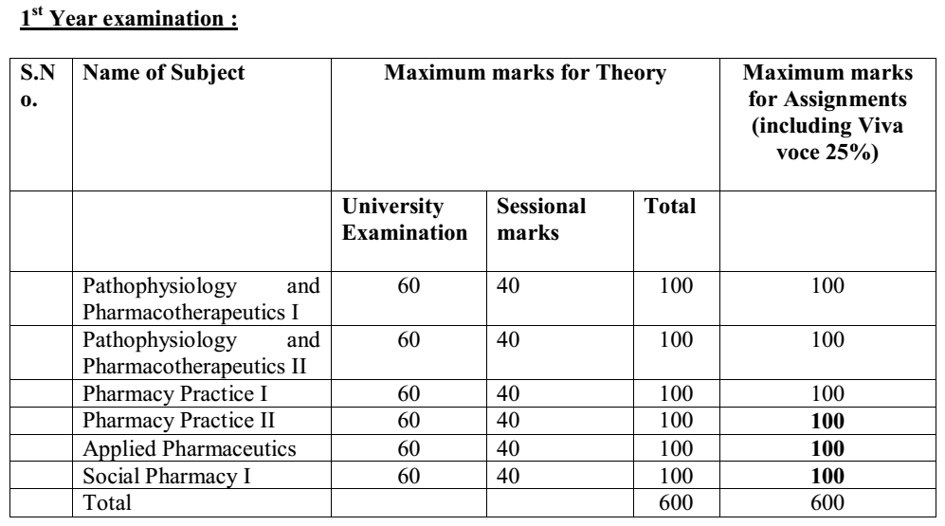
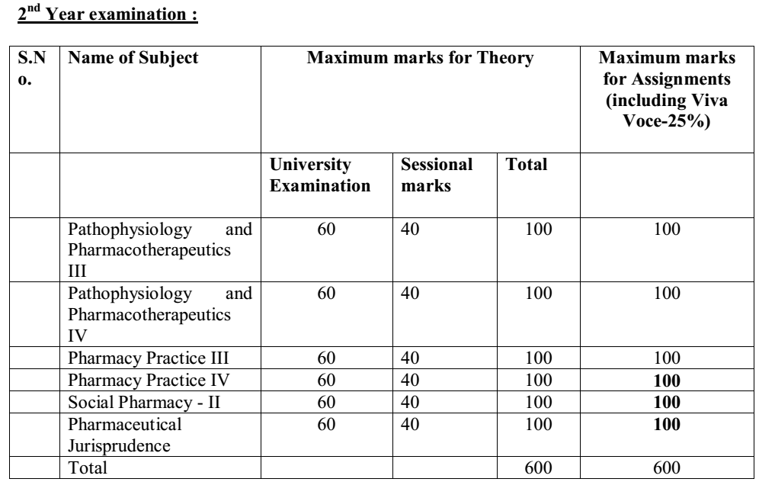

SYLLABUS
